k|yd q}dfl;s k/LIFf–@)*@

sIffM g;{/L k"0ff{° M–%)

ljifo M g]kfnL -df}lvs_ pQL0ff{° M– !*

tn lbPsf k|Zgx?sf] pQ/ lbg'xf];\ .

s_ tkfO“sf] gfd s] xf] ? -%_

v_ tkfO“sf] 3/ stf xf] ? -%_

u_ tkfO“ slt sIffdf k9\g'x'G5 ? -%_

3_ tkfO“sf] :s'nsf] gfd s] xf] ? -%_

ª_ tkfO“sf] sIff lzIfssf] gfd s] xf] ? -%_

r_ tkfO“nfO{ dgkg]{ t/sf/Lsf] gfd s] xf] ? -%_

ª_ tkfO“ sltjif{sf] x'g'eof] ? -%_

r_ tnsf cIf/x? k9\g'xf];\ . -!)_

s v u 3 ª

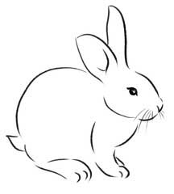5_ tnsf lrqx?sf] gfd eGg'xf];\\ . -%_

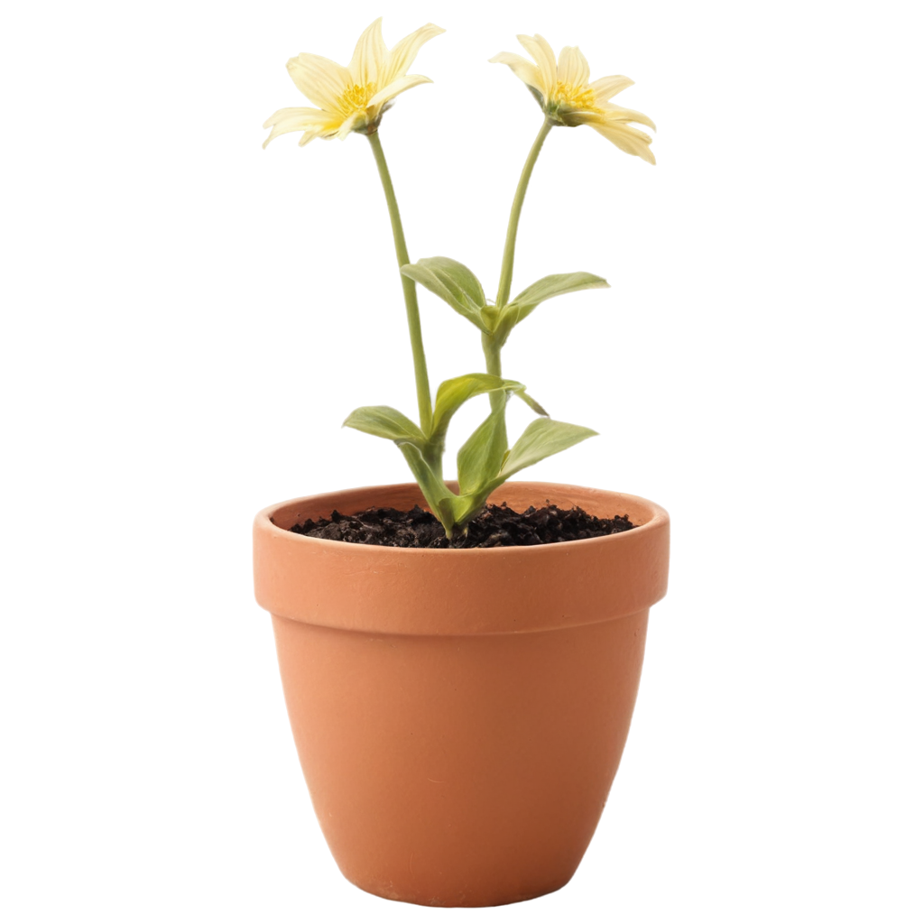





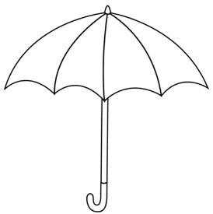

;dfKt